SWE645 – Assignment 1

Name: Aditya Raj

**Overview**

This assignment consists of a static class homepage and a student survey form developed using HTML and Bootstrap. The website is deployed using two approaches as required:

1. Static website hosting using Amazon S3

2. Web application hosting using an Amazon EC2 instance

Part 1 & Part 2: Website Description

- index.html: Class homepage with Bootstrap styling, an image, and navigation

- survey.html: Student Survey form linked from the homepage

- error.html: Error page displayed if the main page is unavailable

**Hosting Details**

1. Amazon S3 Static Website Hosting

The static HTML files (index.html, survey.html, error.html, and assets) are hosted using Amazon S3 static website hosting.

S3 Website URL:

<http://swe645-assignment1-buket.s3-website.us-east-2.amazonaws.com/>

**Steps:**

- Created an S3 bucket with a unique name

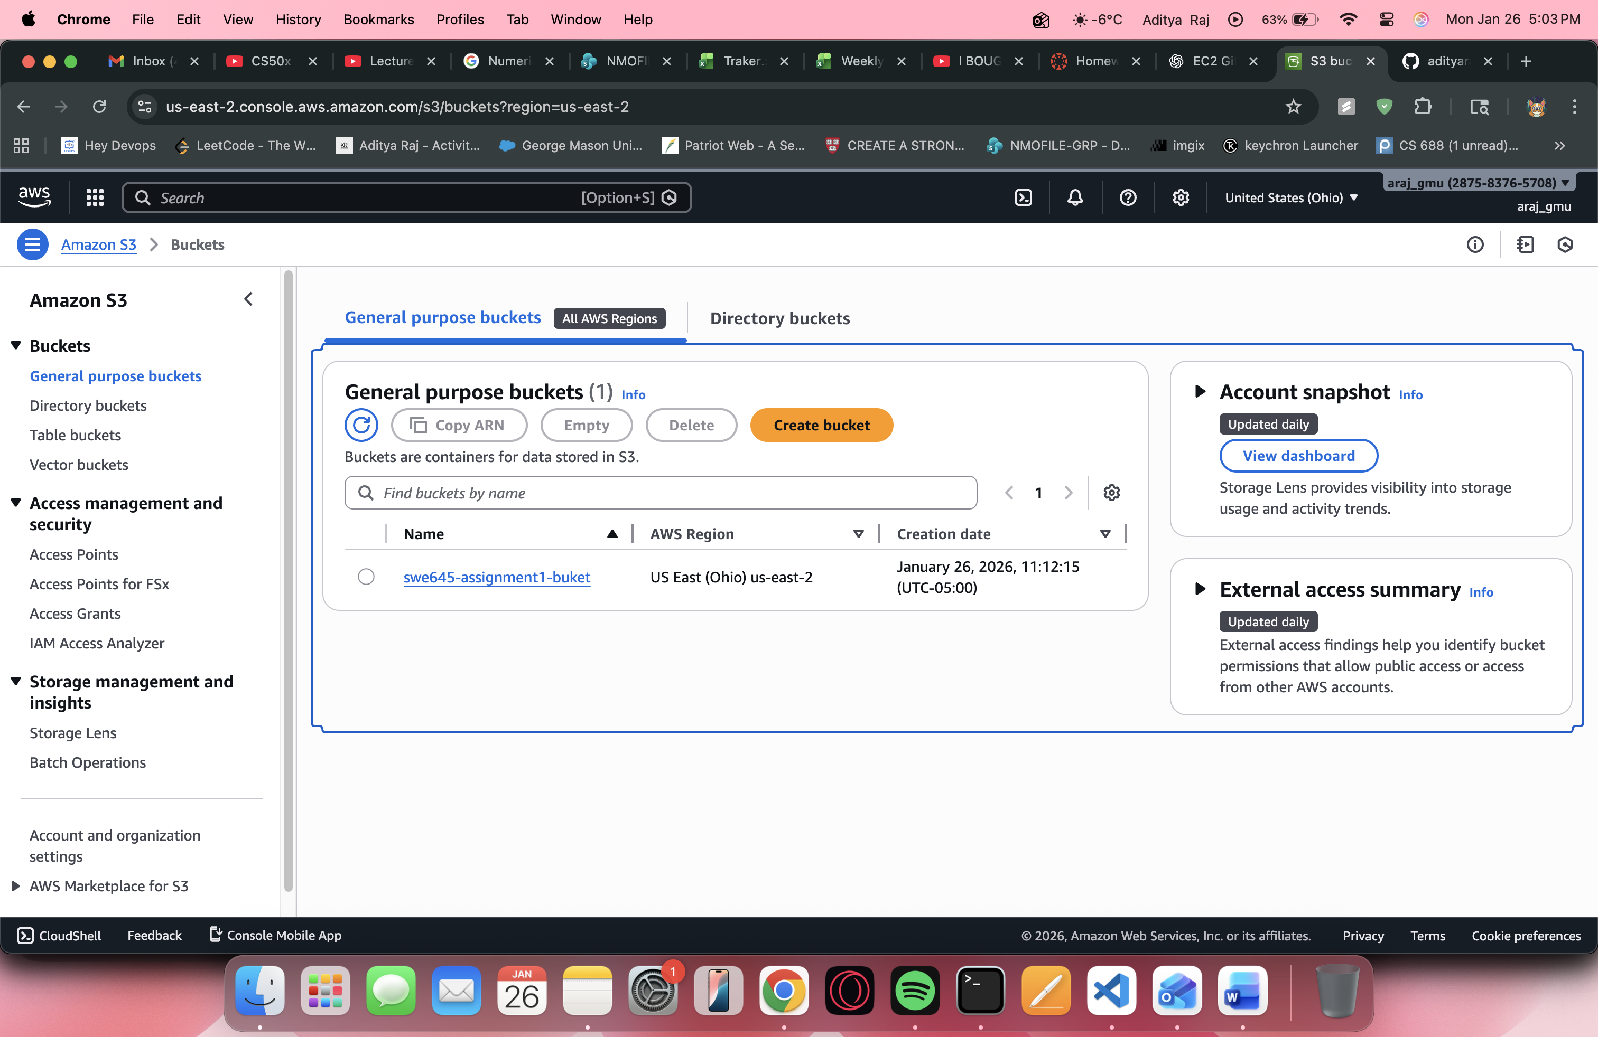

- Enabled static website hosting

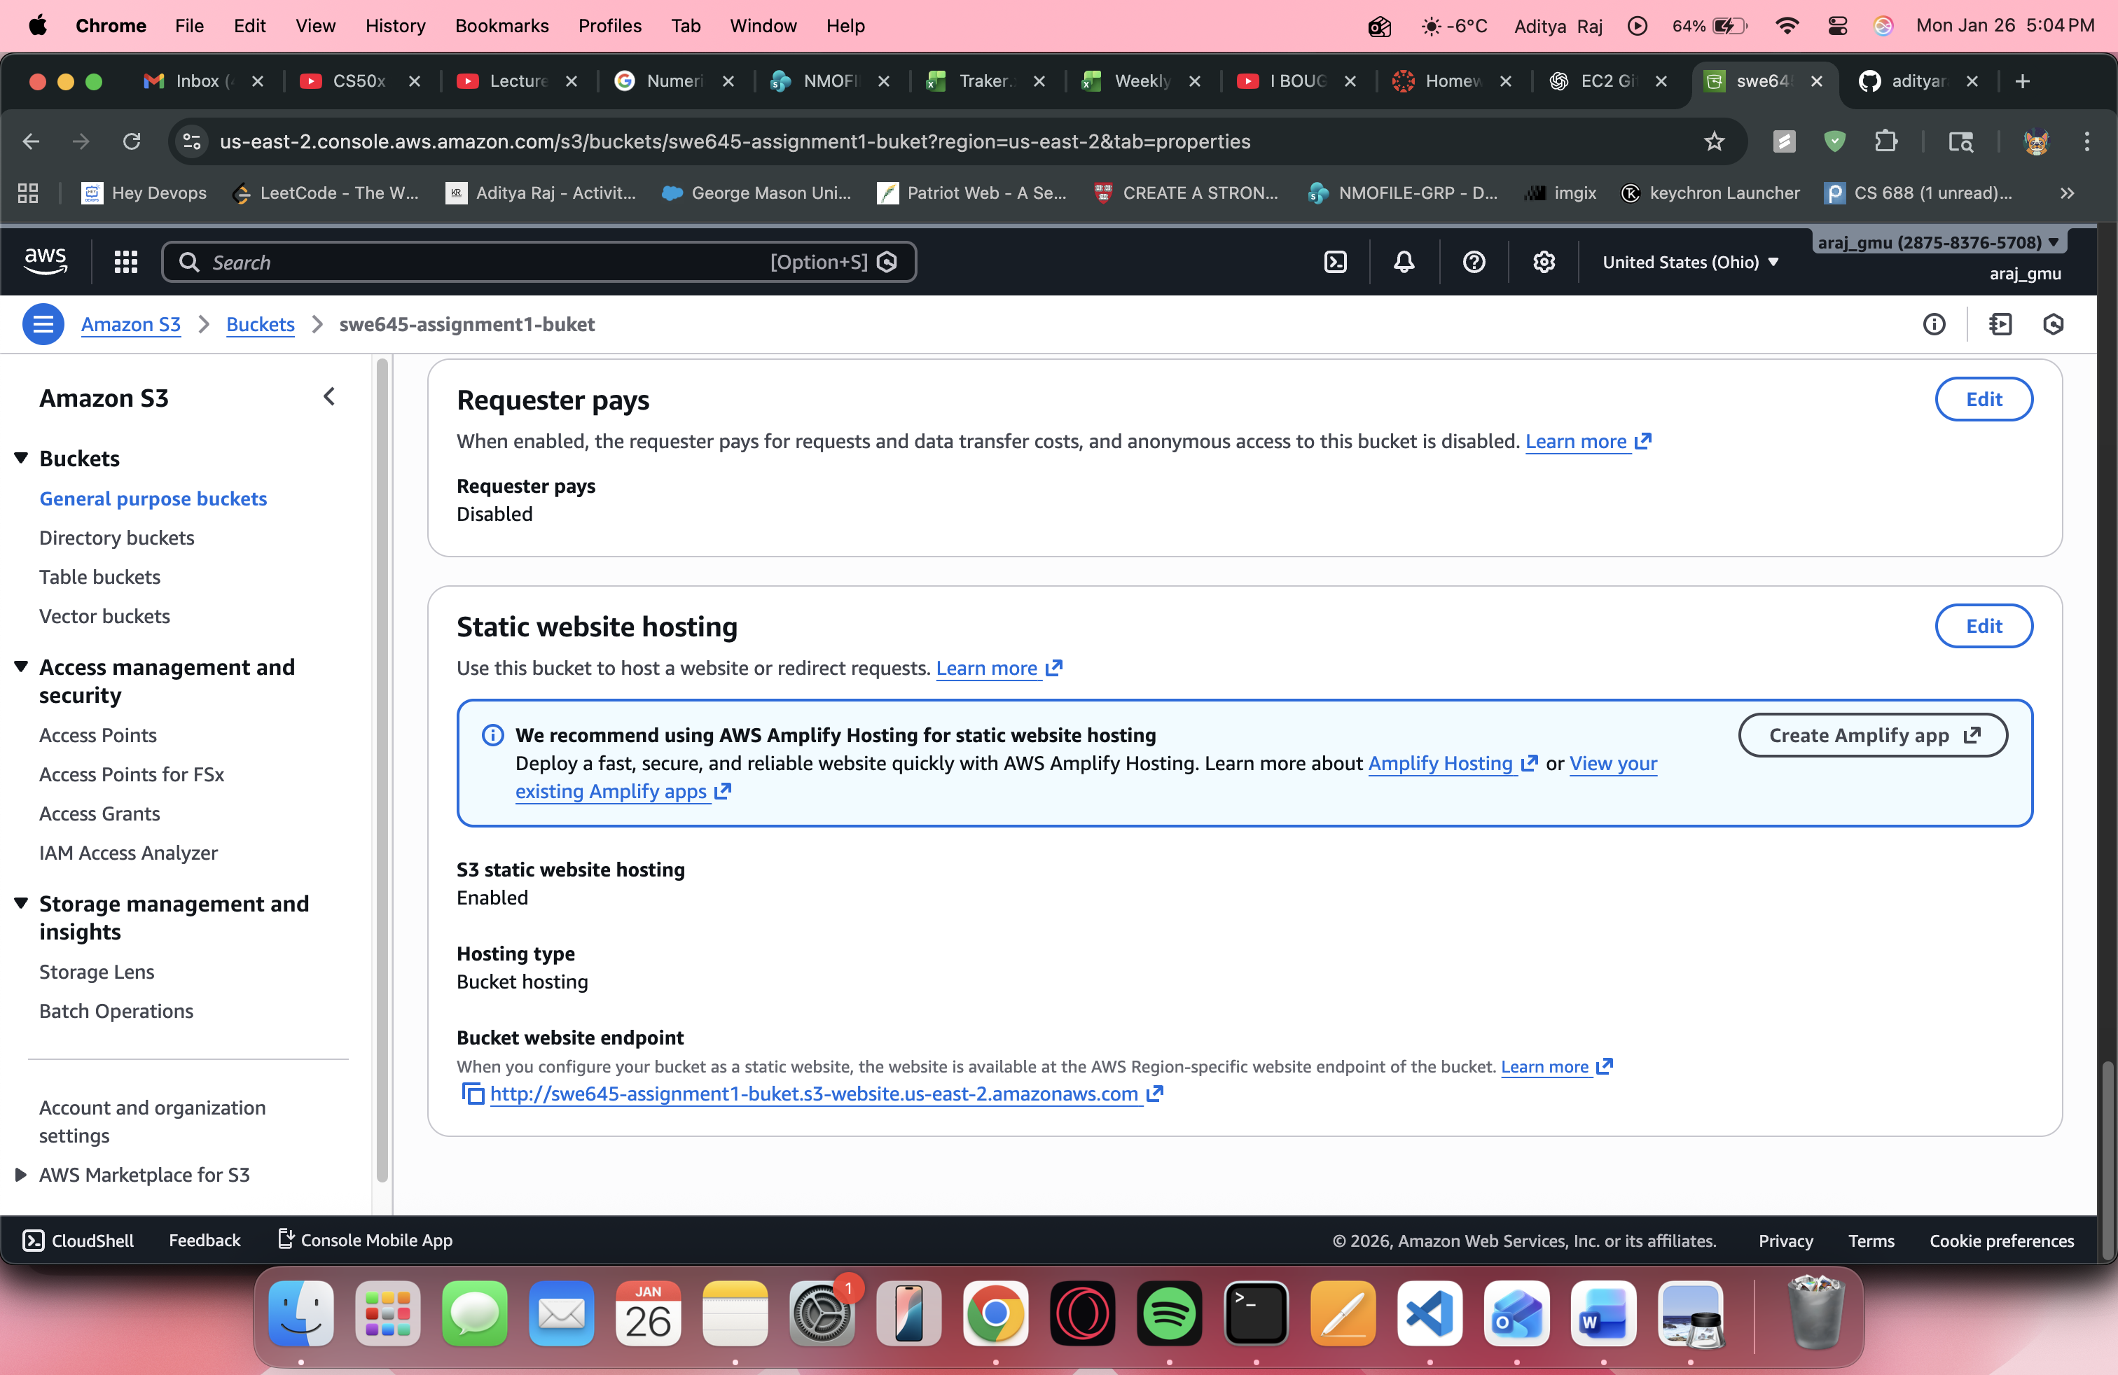

- Uploaded HTML files and assets

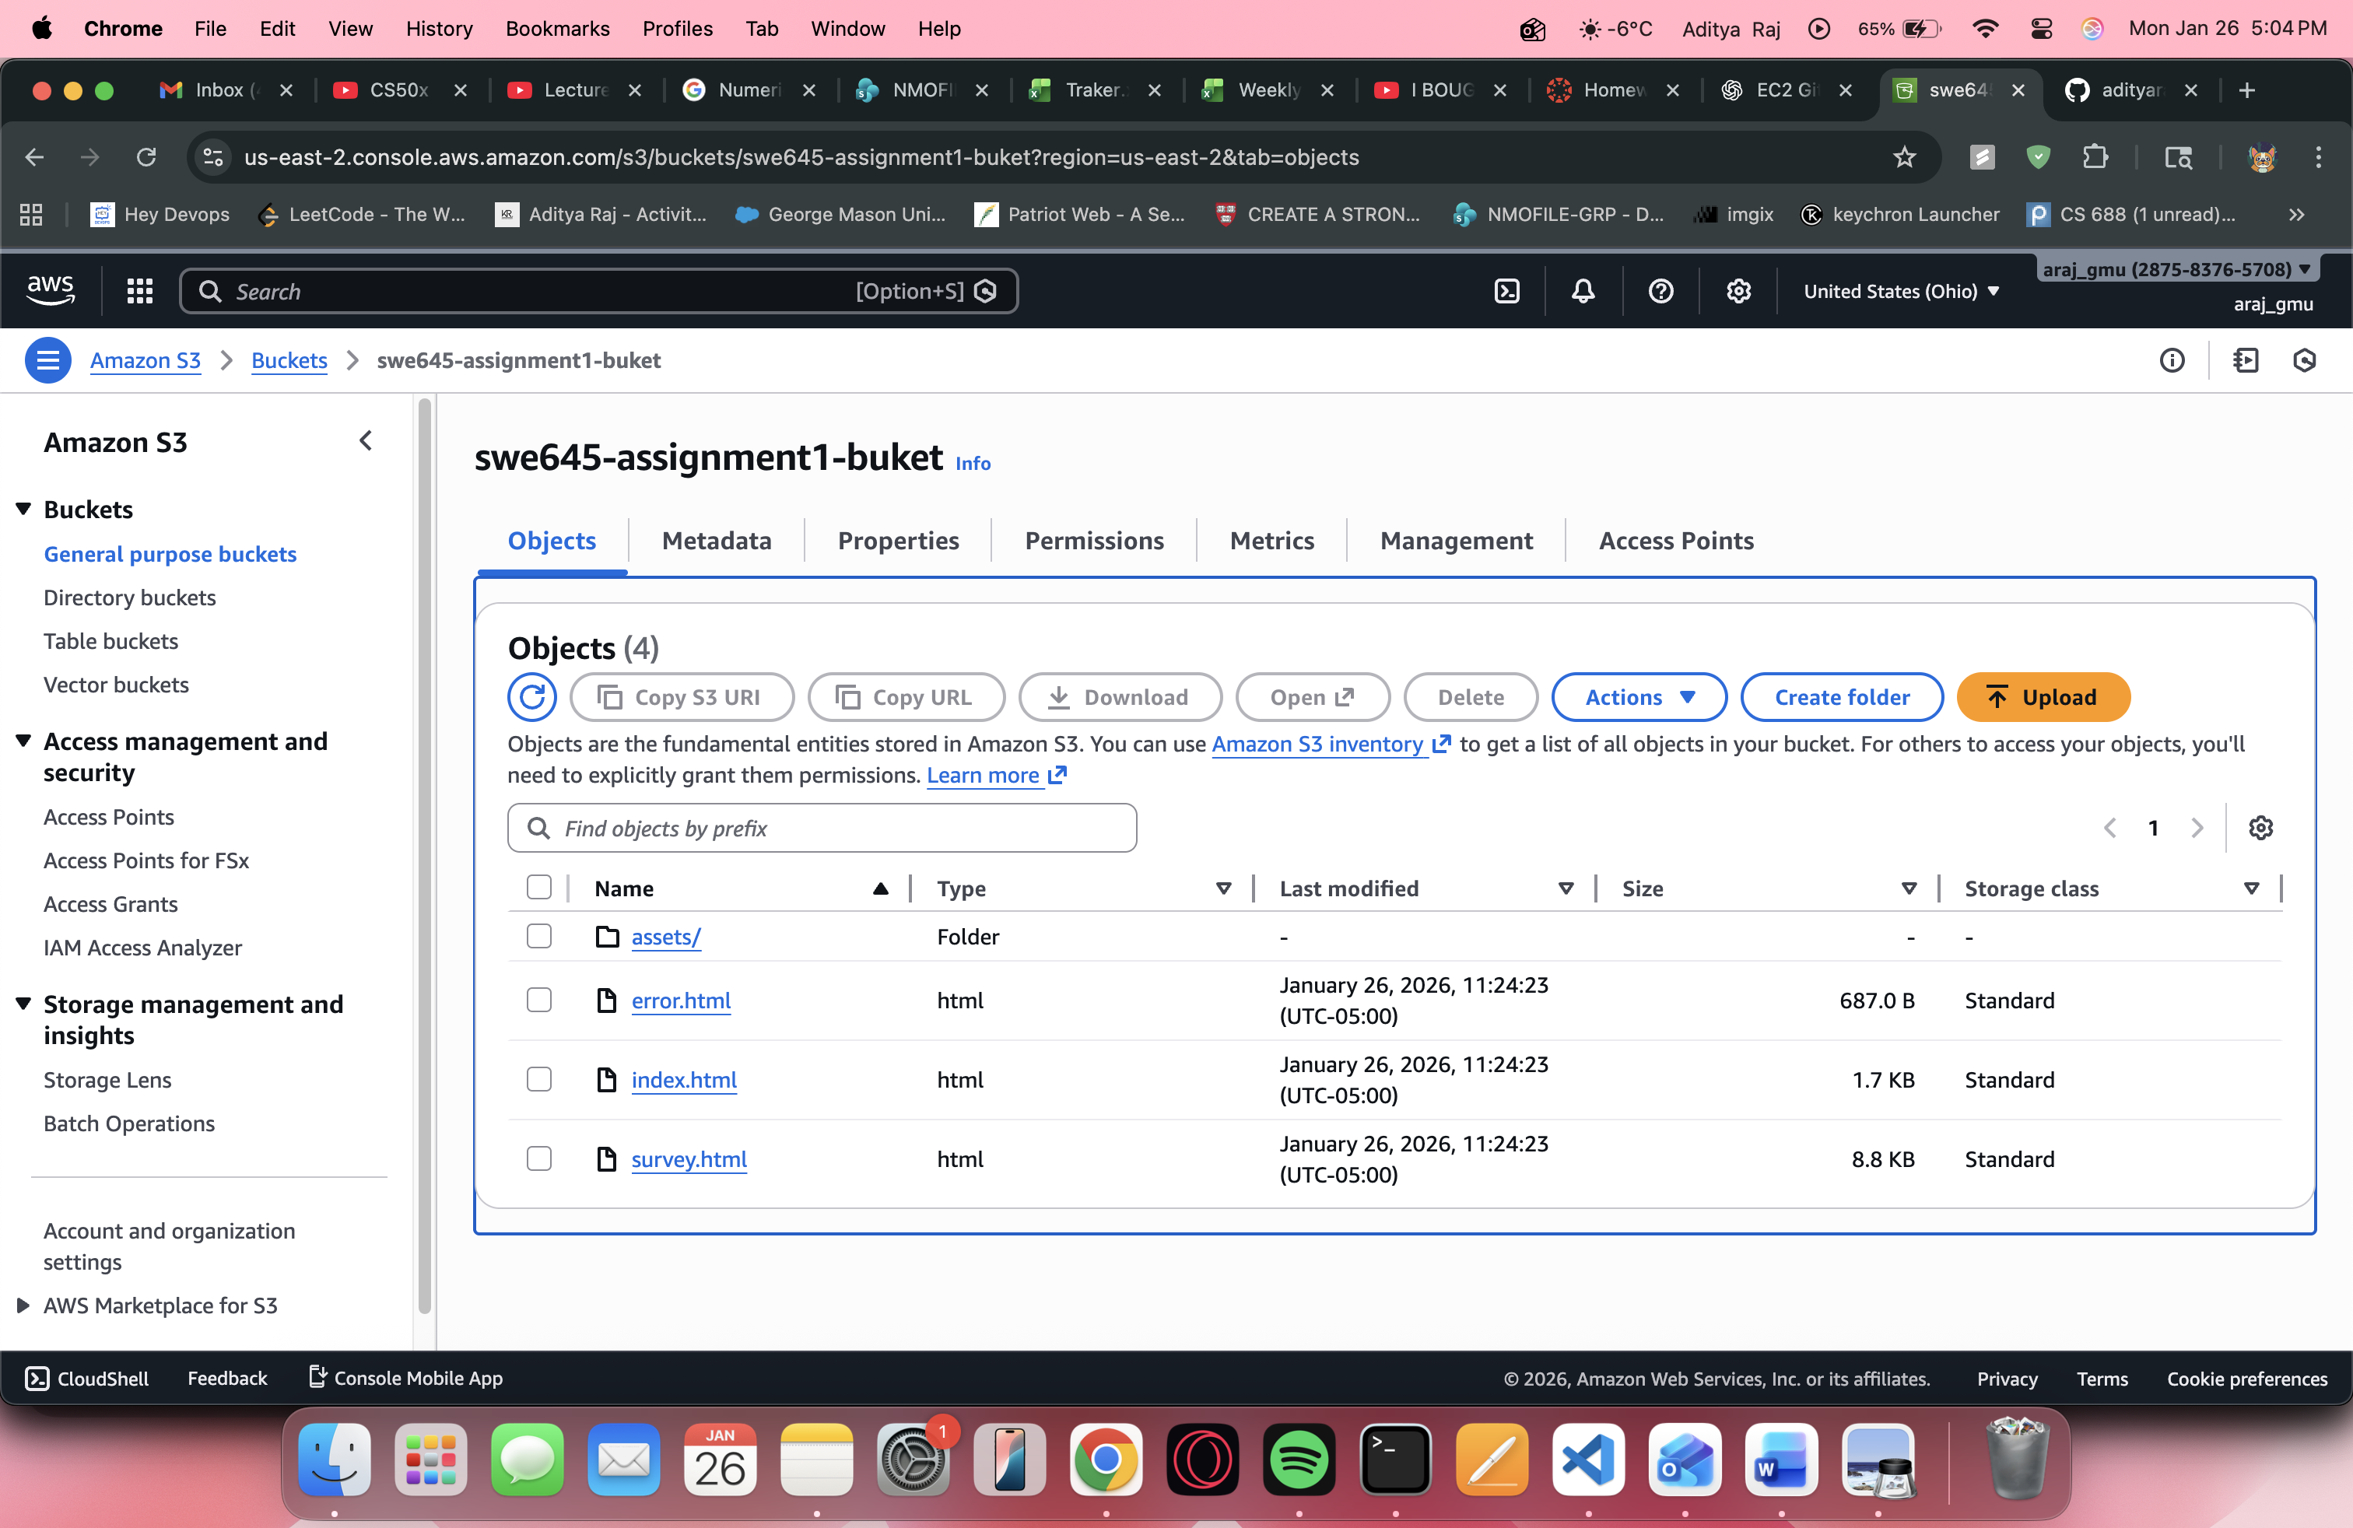

- Set index.html as the index document and error.html as the error document

- Updated bucket policy to allow public read access

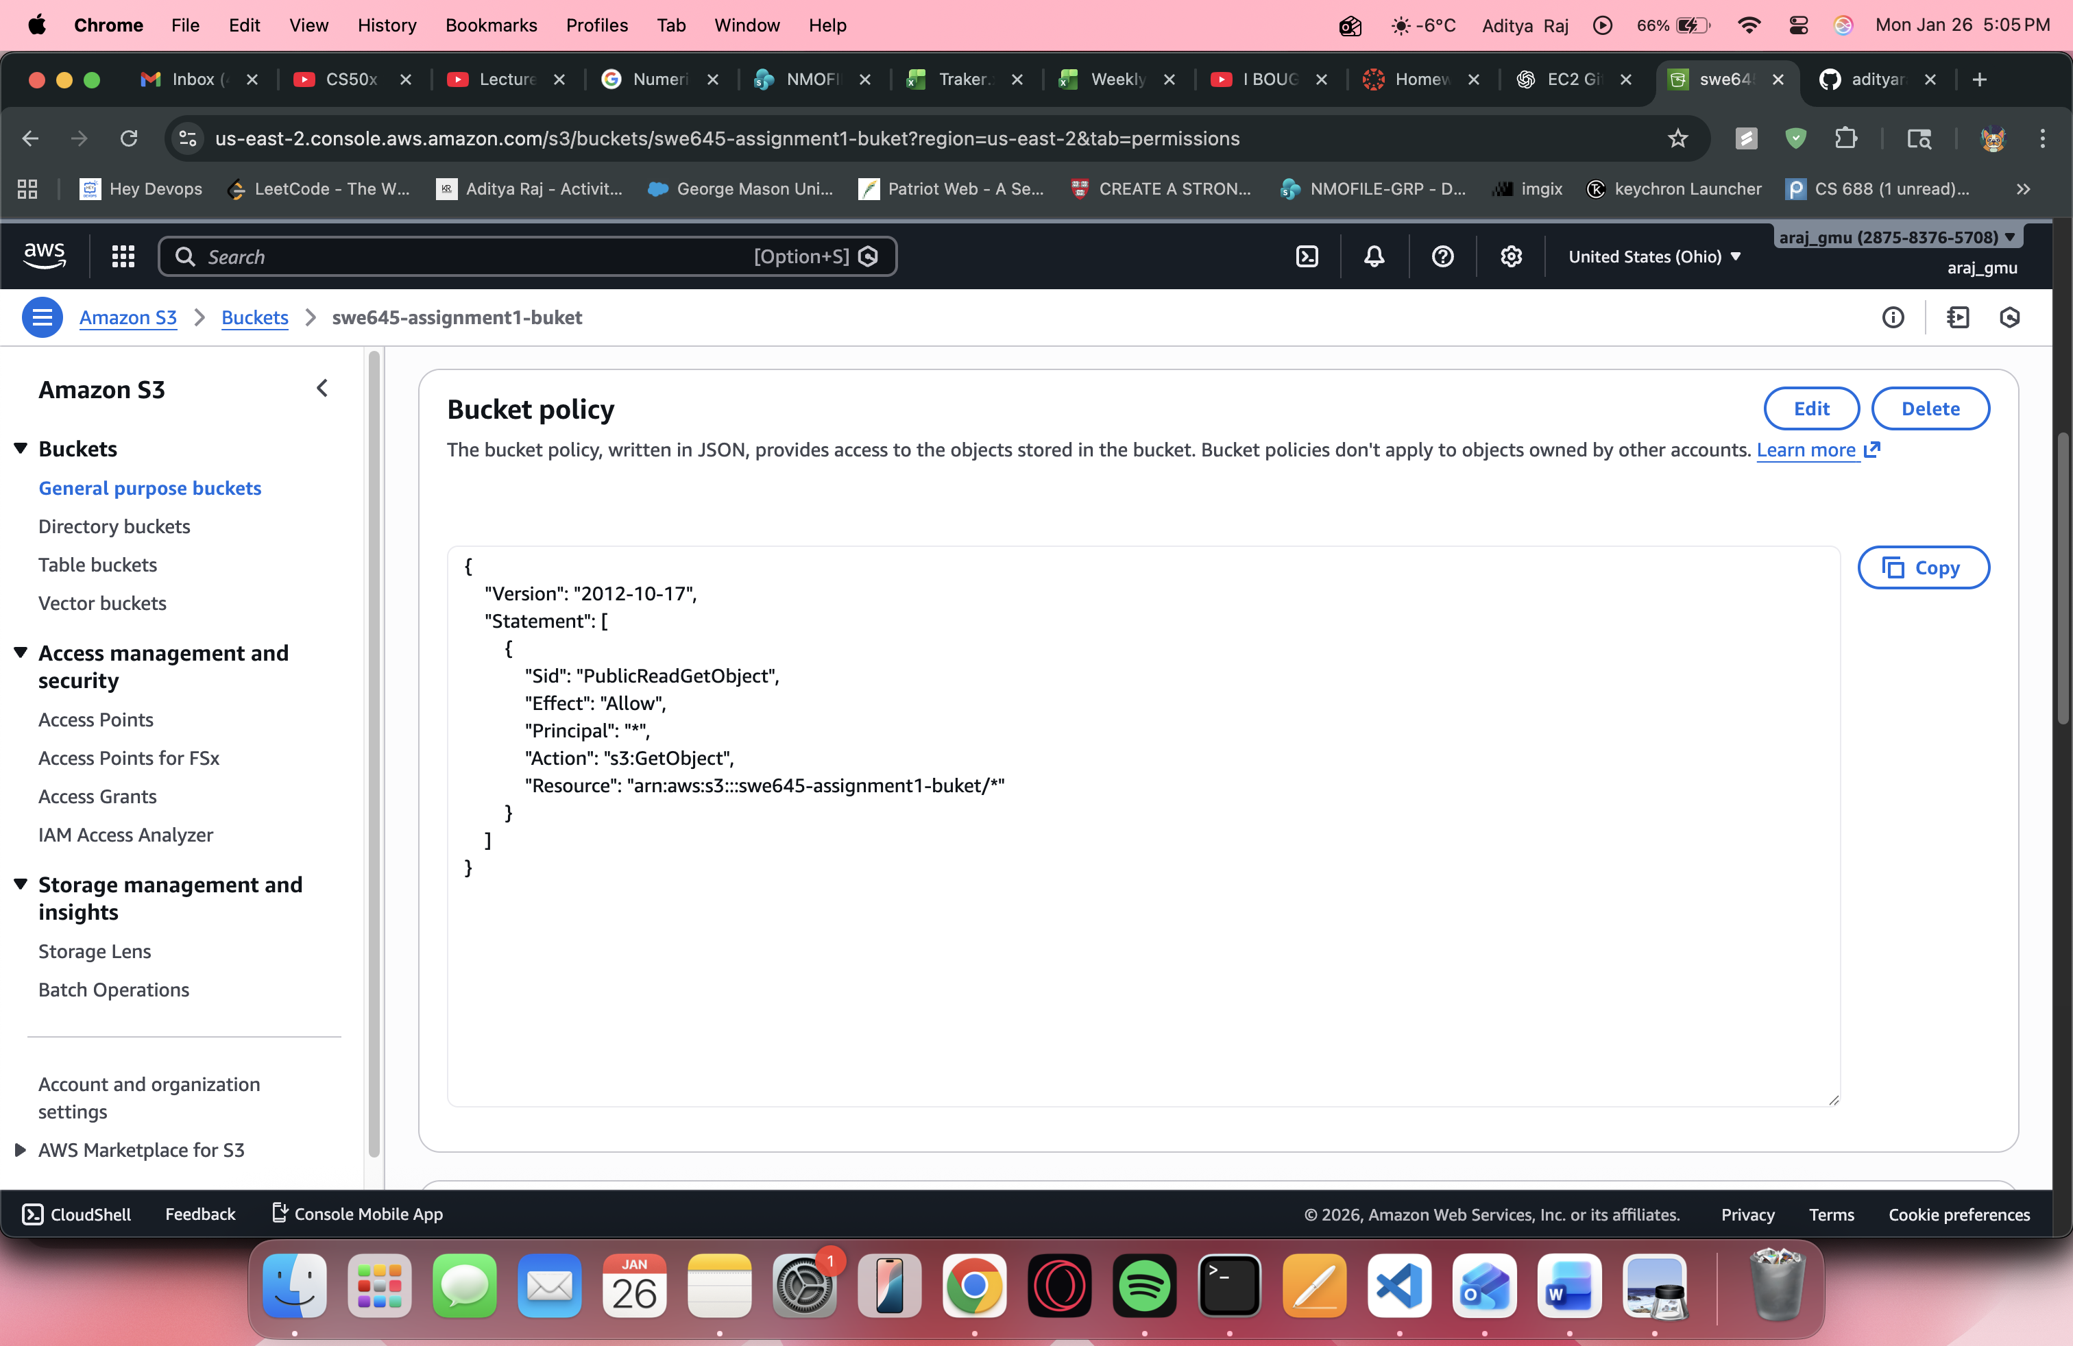

2. Amazon EC2 Hosting

A static website is hosted on an EC2 instance using Apache (httpd) to serve HTML, CSS, and JavaScript files. No Flask or Python backend is required.

- EC2 Instance Type: t3.micro

- Operating System: Ubuntu

- Web server: Apache 2 (httpd)

- Purpose: Serve static HTML pages (index.html, survey.html, error.html) to replicate the website hosted on S3.

EC2 Application URL:

<http://18.222.202.157/swe_645_EC2/>

**Steps**:

- Launch and connect to EC2 instance

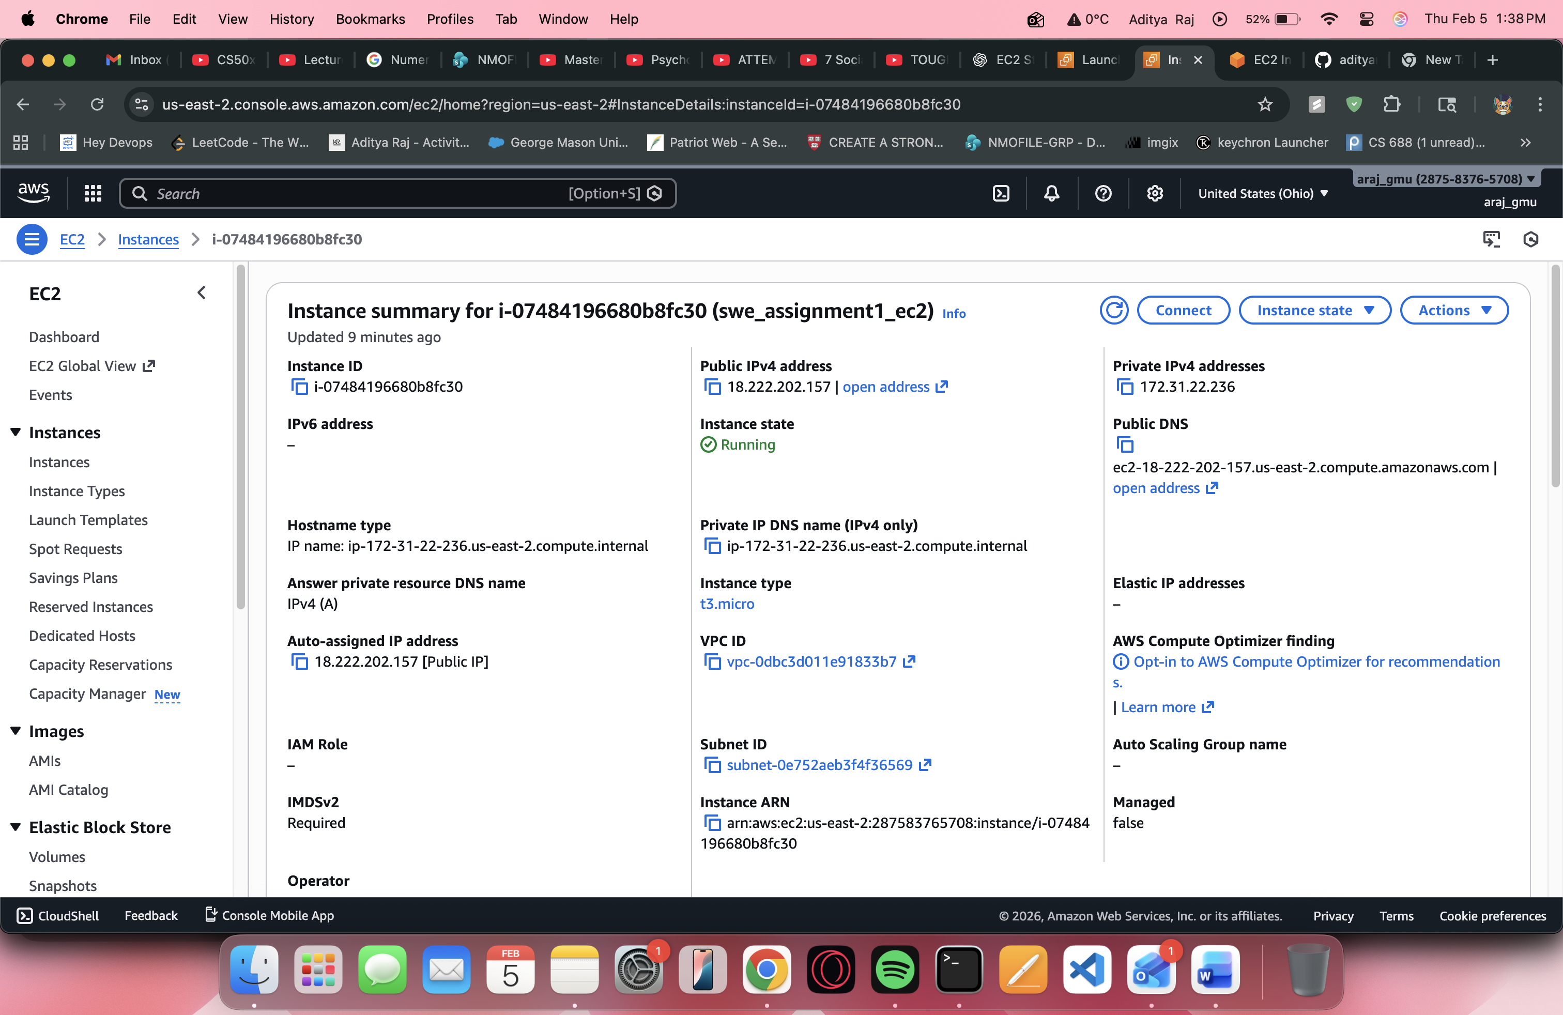

- Install Apache web server

sudo apt update

sudo apt install apache2 -y

sudo systemctl start apache2

sudo systemctl enable apache2

sudo systemctl status apache2

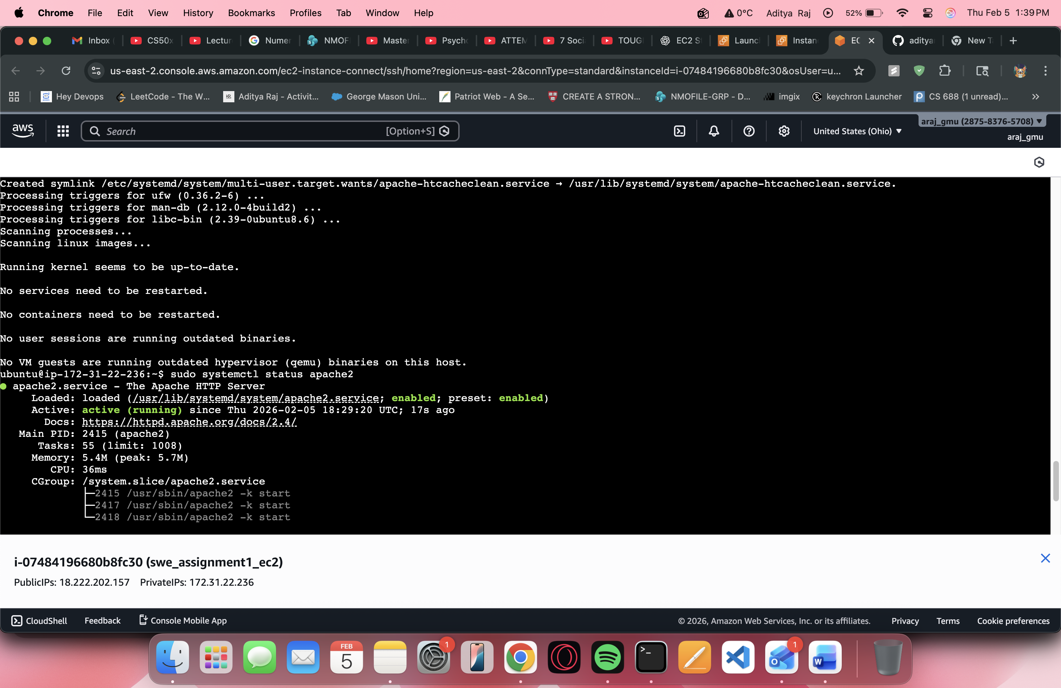

- Deploy website files

cd /var/www/html

sudo rm -rf *

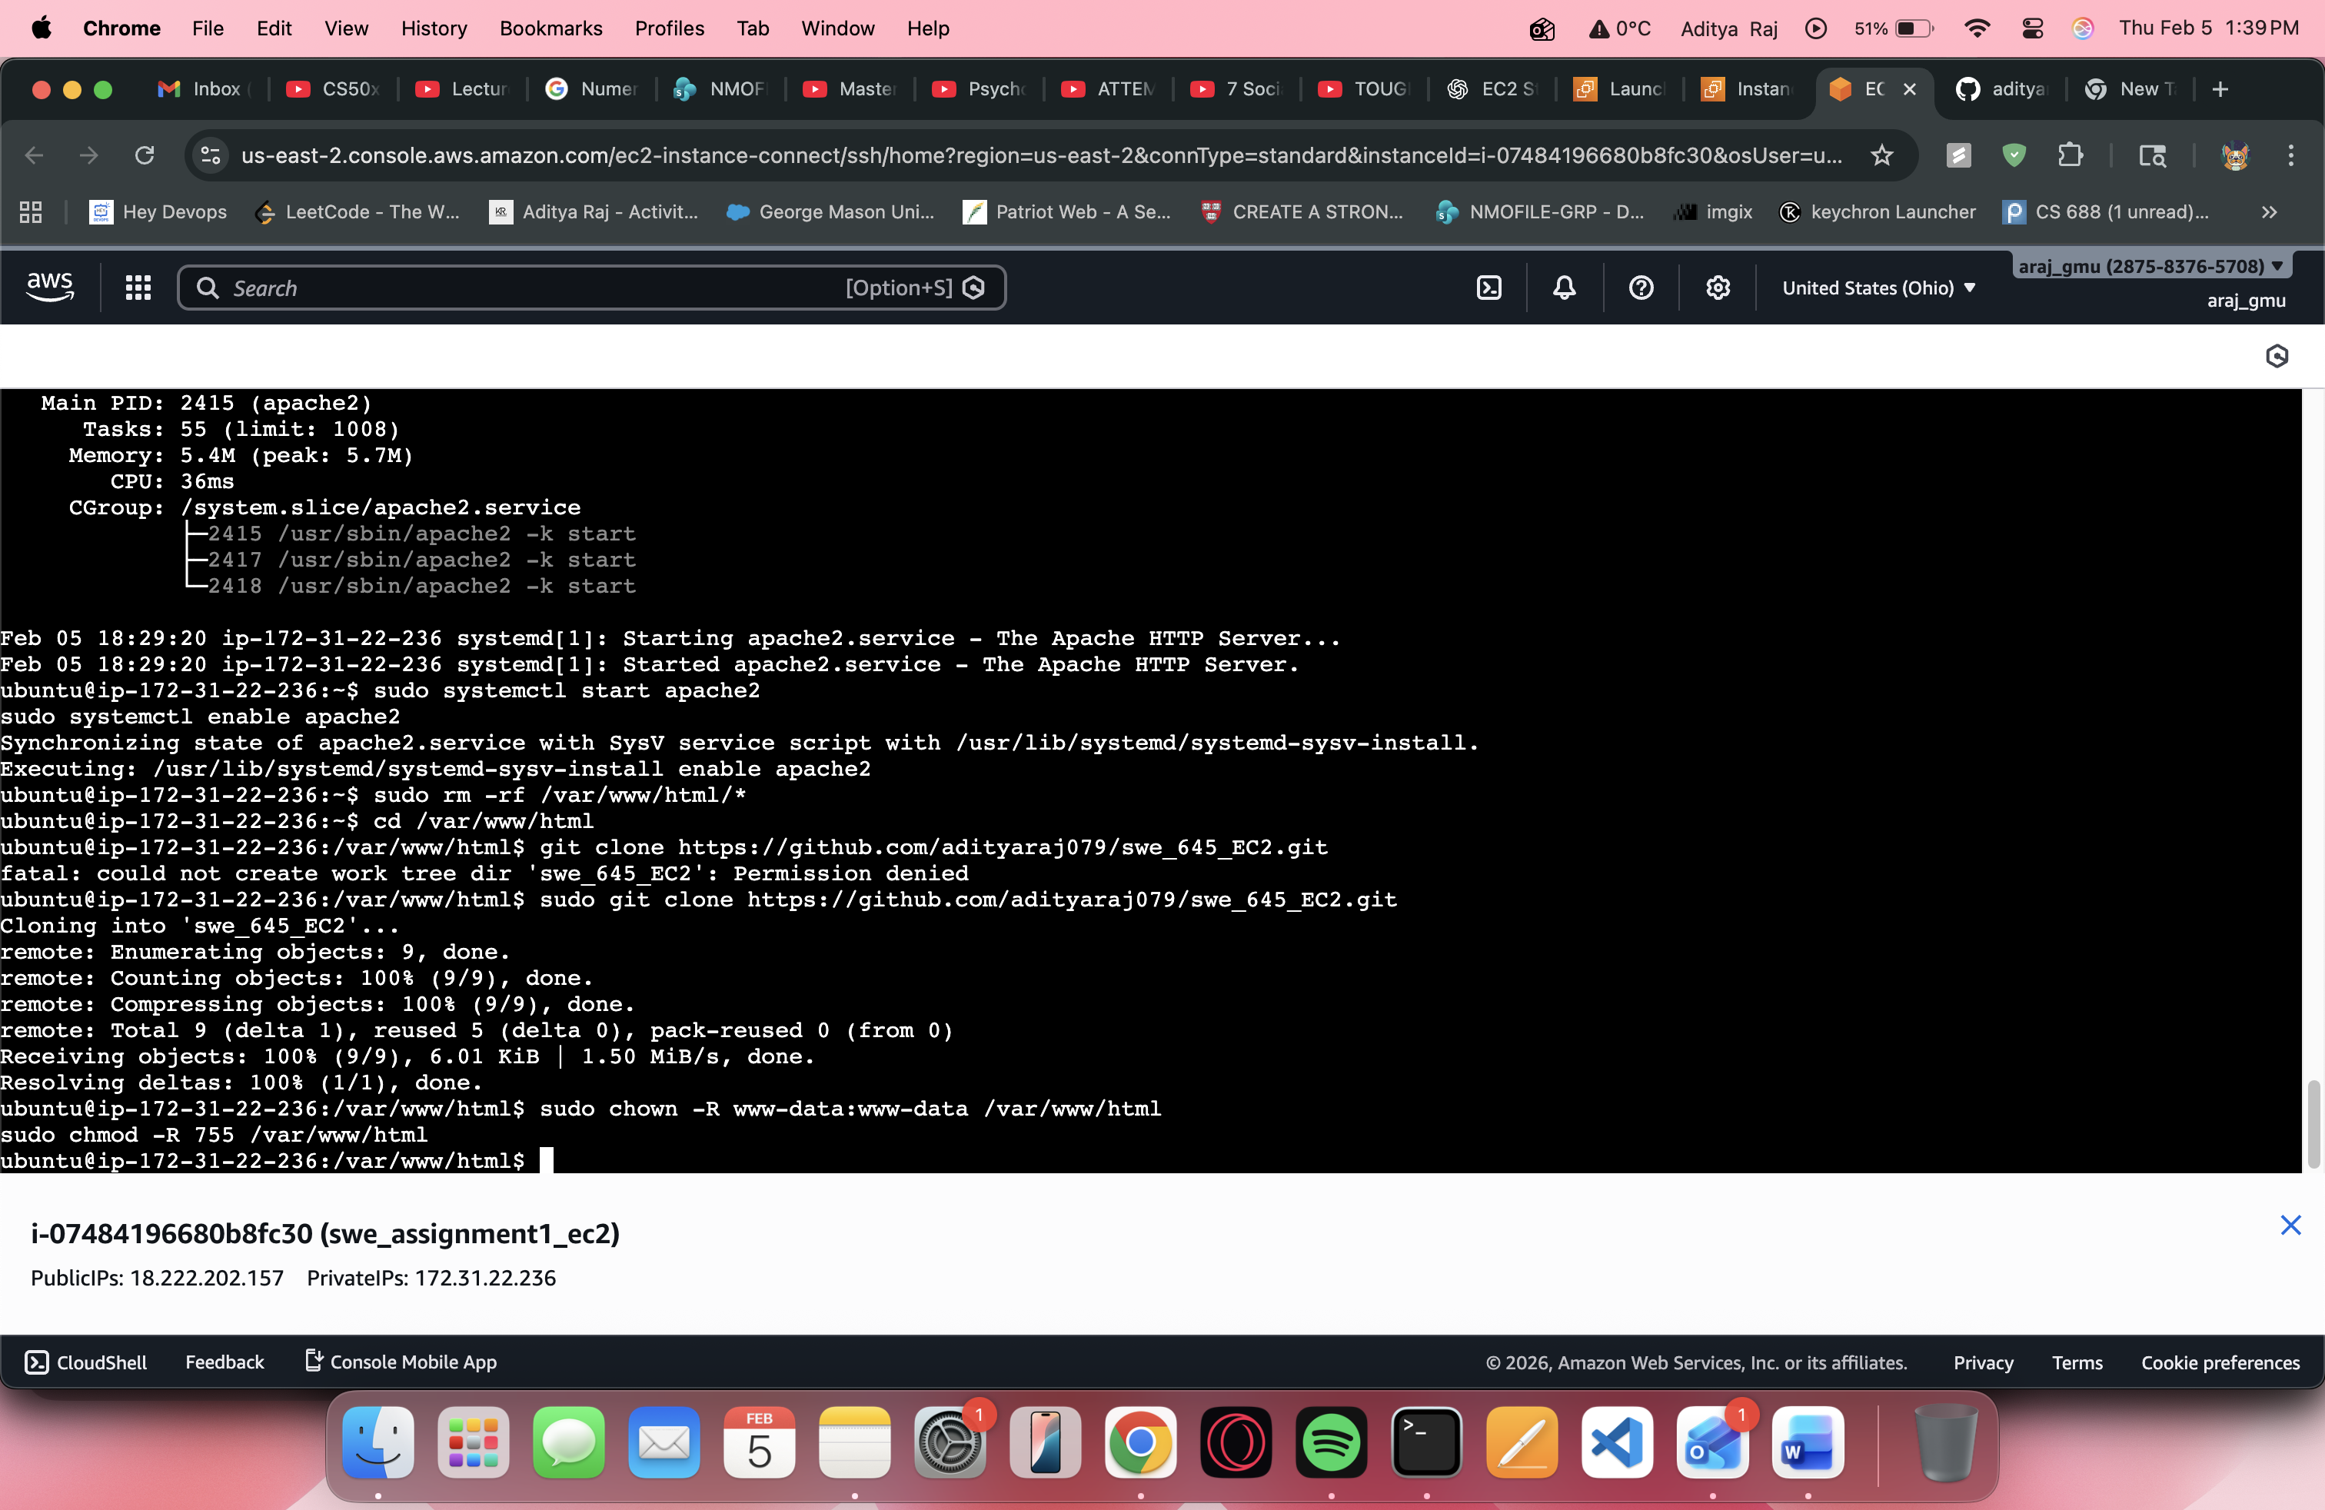

- Copy website files to the EC2 instance through github

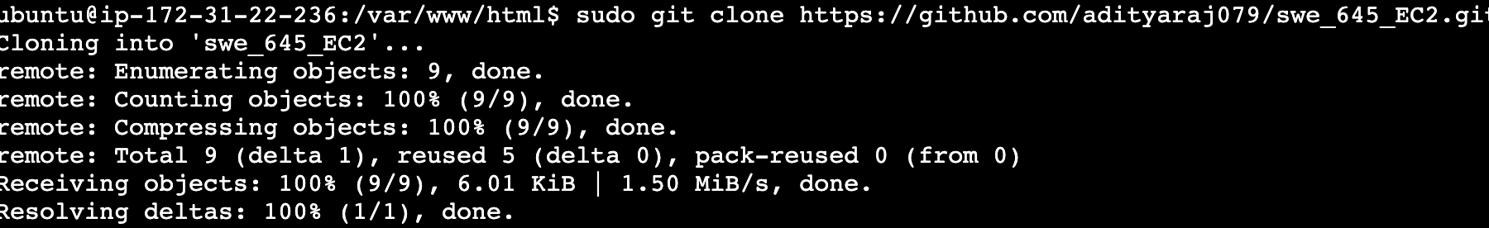

Github repository link: <https://github.com/adityaraj079/swe_645_EC2>

- Set permissions so Apache can serve the files:

sudo chown -R www-data:www-data /var/www/html

sudo chmod -R 755 /var/www/html

-Open the public ec2 in browser

